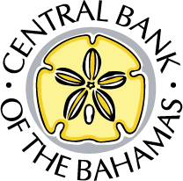

Bahamian Financial Resilience Post-Natural Disasters

John Rolle Governor*
*As prepared for Delivery.

Exuma Business Outlook
Sandals Resort, Exuma, Bahamas
24th October 2019

Introduction
It is always a pleasure to speak at the Exuma Business Outlook. This is happening at a time of incredible change within our economy. We are paying more attention to the immediate and long-term needs for planning and development around financial and economic resiliency; and on leveling the playing field of access for commercial goods and services. Post-Hurricane Dorian we are now more focused on strategies for financial resiliency for households, businesses and the public sector; and we are preoccupied with business continuity and recovery at the national level for critical financial services.
The take away from my presentation is that alongside the interventions which the Central Bank intends to make to increase the preparedness of the banking and payments system, serious interventions will also be needed from a policy and cultural perspective to tackle the household sector’s financial vulnerability. Critical evolution is also required in our tourism product model to make this leading foreign exchange earner more resilient.
The Central Bank will continue to take a progressive approach to identifying and promoting legal and regulatory reforms to accommodate financial sector transformation in the direction of greater resilience.

General Impact of Natural Disasters
For the better part of the last two decades, The Bahamas has been experiencing the direct impacts of climate change, particularly as it relates to the passage of tropical cyclones (hurricanes). They have increased in both frequency and intensity. Since 1999, there have been at least eleven named storms that had a notable impact on some part of the archipelago. These storms have had the foreseeable impact of disrupting economic activity in both the immediate and medium-term, as shown in reduced output, rise in unemployment; and in placing great strain on government’s finances. Before Dorian, Hurricane Matthew (2016) exacted most recent high toll, even posing an obstacle to the government’s then articulated medium-term fiscal consolidation plan.
The impact from Hurricane Dorian is projected to be greater than Matthew’s. In the monetary and financial sector, setbacks include the disruption in banking and payment services; and a potential deterioration in banks’ credit quality indicators as borrowers in the impacted zones encounter a lengthy period of reduced or eliminated incomes.

Policy Responses & Preliminary Estimates of the Impact of Hurricane Dorian on the Banking Sector
Immediately following the storm, the Central Bank – consistent with actions taken after other severe encounters – relaxed lending guidelines for domestic banks on a temporary basis. Specifically, in relation to hurricane relief facilities, the 15% equity or down payment contribution and the 40%-45% debt service ratio (for directly impacted borrowers) were waived in order to facilitate easier, flexible access to credit. Additionally, the Bank endorsed temporarily relaxed due diligence procedures for money transmission businesses (MTBs), given the loss of vital documents for customers in the impacted areas.
For their part, commercial banks suspended loan repayments for borrowers in the affected areas for a period of up to 6 months. In addition, with the absence of bank branches, the customary fees on ATM usage were voluntarily suspended on Abaco and Grand Bahama.
Our commercial banks are not under any unmanageable financial stress because of the Grand Bahama and Abaco outages. These institutions have comfortable levels of capital to absorb any losses that might materialize, and they are still collectively in a position where their capital levels will need to be reduced over the medium-term. Most of banks’ credit exposures are to New Providence, where economic activities remain intact. The Central Bank’s stress testing simulations show that in a very severe, major hurricane, that might be the case if damages were concentrated in New Providence, banks could face significant loan losses, but would still be able to withstand the setback generally, from their existing capital buffers. Where this picture could evolve in an unsettling fashion however, is changing expectations on the frequency of major shocks, since the system would need sufficient time to recover between events. This takes us back to the issue of having overall macroeconomic resilience, to contain the extent of losses for any major or successive storms.
In terms of financial sector exposure, commercial banks’ credit portfolio for Grand Bahama and Abaco totaled approximately $830 million over the July-September 2019 reporting period, which accounted for around 14.8% of total private sector credit. Collectively just over half of the exposures were mortgages. Moreover, Grand Bahama represented about four-fifths of the total credit—which is good in the context of the faster pace at which this sub-economy is expected to recover. At the outset, the non-performing loans rate was higher in these northern islands.
As we consider the impact and recovery from Dorian, the general outlook for the Bahamian economy is for some setback in the near-term, with the revised growth projection still positive for 2019, but at less than the levels forecasted prior to the storm’s passage. In 2020, the outcome could be flat to negative, with a return to positive territory in 2021. The recovery path in both of the affected islands will initially be dominated by extensive rebuilding activities, which will heighten the demand for construction-related skills and services. This should partially offset the contraction in activities other economic sectors.
The private sector component of the rebuilding activity will be partly financed by external reinsurance proceeds. The Government will also rely on foreign currency resources. This hints at an important element in our resilience to natural disasters: that rebuilding relies on imports that must be financed with foreign exchange, at the same timing as when the tourism earnings are disrupted. Resiliency amounts to being able to withstand such shocks without putting the survivability of the Bahamian dollar exchange rate into question. Reinsurance payments inflows will offer a cushion of at least $0.5 billion to foreign exchange needs. These will be the largest such inflows levels ever received (see chart).
In reliving these experiences in the future our national savings must also stay present in the form of the external reserves of the Central Bank. As The Bahamas is able to build up these buffers, we would create space to use more local currency resources to rebuild. On the projected recovery path, our foreign reserves will experience a boost initially from the re-insurance receipts and proceeds from government financing. These are expected to be consumed in full next year, with the expectations that The Bahamas could end 2020 with slightly lower foreign reserves than at the end of 2018.
The ability to see some return to activity in Grand Bahama in 2020, favors the onset of the recovery of tourism earnings. Having the Abaco tourism plant substantially back in production by 2021 would help to normalize return to the still positive medium-term outlook for reserves. Until then, the tourism marketing strategy has to succeed in attracting some of the displaced business from the northern islands to undamaged facilities elsewhere in The Bahamas.

Resilience Post-Natural Disasters
At this point, I would like to delve deeper into the topic of resilience.
Drawing on the work of the IMF, the World Bank and others, a framework for building resilience would consider three major elements: the physical or structural infrastructure, financial factors and the social, post-disaster resilience. I will keep the focus today on financial resilience. That said, both social and infrastructural vulnerabilities still reduce to financial costs that ought to be addressed in policies that build buffers and provide ample insurance for both public sector interests and private households.

Financial Resilience
For the public sector, the World Bank and IMF inspired multi-layered approach to managing the fiscal and macroeconomic risks of natural disasters focus on four areas. They include:
- Fiscal buffers (as a means of self-insurance)
- Securing direct insurance (through risk-pooling mechanisms)
- Pre-arranging emergency access to credit (for rapid response)
- Securing access to international financial and humanitarian assistance
The Bahamas has made particular recent progress in the second and third areas, with access to the Caribbean Catastrophe Risk Insurance Facility (CCRIF) and through a pre-arranged line of credit with the Inter-American Development Bank (IDB). Self-insurance will likely have a greater impact on resilience over the longer-term, as evidenced by our ability to generate annual budgetary savings, and to reduce the public debt burden. This would make it possible take on extra debt if necessary—and without concern—after natural disasters. Fiscal savings could also purchase larger amounts of insurance in the market and finance larger natural disaster funds, both of which are debt avoiding strategies. Further, buffers accumulate in terms of how infrastructure is rebuilt and in some cases relocated, at greater upfront cost, to resist extensive future damages from major hurricanes and sea level rise.,

Financial Resilience for Private Sector/Households
Another major consideration for the post-disaster phase is the exposure of private sector agents (households and businesses) to losses. In particular, a significant number of uninsured or under-insured homes exist in the damaged zones, which is a snapshot of a greater national prevalence of the same, particularly among lower income homeowners who find it financially challenging to purchase insurance coverage.
This presents a significant financial risk to the Government! Fiscal costs mount when these exposed interests require some subsidized level of recovery. For inadequately insured middle and upper middle-income families, or small businesses, public subsides are not likely to provide either timely or full restoration of their former circumstances; and some losses may become permanent. This is a vulnerably that still has to be meaningfully addressed, through households and businesses taking on more active responsibility for it, and through intentional public policy to reduce the financial risk to the government.
A philosophy which stresses that Bahamian households should prudently manage their finances over a life time perspective is important—especially with mounting climate change vulnerabilities. Just as in the case of the government, the household’s approach to savings should allow families to insure better against the setbacks from natural disasters. Insurance has to factor into the cost of housing, just as should tax and other maintenance obligations. A part of the solution is accepting downsized housing, for which families can more fully afford the insurance. We must also be able to afford more resilient physical dwellings. Aside, from being cautious about the coastline, it could mean more acceptance of multi-family condominium style structures, built more elevated and able to withstand higher winds forces than single-family housing. Accepting the premise that some families are not going to be voluntarily disciplined then public policy would have to cause the insurance to be secured. This speaks to taxpayer funding on some direct level.
Having savings buffers also means that our families have to be more conservative about their debt levels in ordinary times. Even with the relaxed position that local lending institutions are now taking to accommodate borrowers after the recent storm, there will be some families who are be unable to take on more debt to finance necessary home repairs or to replace lost assets. Again, this means more scrutiny of the expenditure levels that families take on in ordinary times. The policy intervention from the Central Bank side would lean towards tighter lending standards for households that are not yet in distress.
At the national level, regulation on lending standards will also need to reflect uniformity across entities that are not supervised by the Central Bank. It is a macro-prudential concern—meaning that it could undermine the stability of the financial system in a general sense, if left untreated. In the extreme, it could affect how the economy in the aggregate is able bounce back from natural disasters.
The Central Bank’s medium-term approach will be to also explore how the incidences of under-insurance on mortgaged properties could be suppressed. The financial distress from underinsurance can be particularly acute when debt survives that has to be repaid, despite major loss of the physical assets.
For the business sector, affordable bridge financing will also have to be in greater abundance post-natural disasters. The Central Bank is already committed to studying this issue of how even larger volumes of resources can be accumulated for such purposes. Again, the outcome is likely to target savings in funds that are only accessible for lower cost financing after natural disasters.

Enhancing Financial Resilience Through Technology
Moving from households to financial institutions, technology will have to feature more prominently in our resilience and recovery plan. Indeed the recovery of access to financial services is vital to restarting commercial activities. Payments services have to be present for businesses to operate; for the government and aid agencies to effectively dispense financial assistance, and even to make use of early payouts from insurance policies. At present, there is still too much dependence on cash handling services and therefore commerce is only able recover clumsily, when the physical support that banks provide is missing or hampered.
Fully accessible and enabled digital mobile payments would resolve many logistical challenges at once. Project Sand Dollar has the potential to deliver this longer-term resilience. It would permit wireless restoration of payments connectively, avoiding the cash shipment and cash handling frustrations. It would permit electronic dispersing of aid; and allow families to recapture personal dignity, by restoring the flexibility to prioritise the elements of personal need that they prefer to satisfy post-disasters.
One of the impacts of the recent hurricane on the country’s banking sector was the significant damage to physical structures in Abaco and Grand Bahama, which also shut down operations on those islands. Critical to restoring a sense of commerce is the timely resumption of banking and payments systems.
For this reason, the Central Bank is exploring an early entry of Project Sand Dollar into Abaco. It will allow the Bank to test aspects of the emergency wireless communications features that would enable rapid financial services recovery; and to connect with many retail businesses early in their recovery process. The Sand Dollar infrastructure is being designed to connect with bank accounts, so that remote access to these facilities is also quickly re-enabled for deposits and withdrawals.

Tourism Sector Resilience for the Fixed-Exchange Rate Regime
I started to touch on the stability of our fixed exchange rate regime and the value of the Bahamian Dollar earlier. For the medium and longer-term this amounts to making the foreign exchange earning assets more resilient. Hotels and other onshore accommodations are The Bahamas’ most valuable and most exposed assets. Damages to Abaco are most summarized by the extent to which these assets have been taken offline. In 2016, Hurricane Matthew similarly resulted in the loss of much of Grand Bahama’s room inventory, compounding the decline in the island’s tourism output which had already been entrenched.
If the Bahamas is to cope better with more frequent and intense tropical cyclones, it needs to be able to keep more of its income producing resources out of harm’s way. One way to do this is through direct ownership over more mobile infrastructure. The cruise industry does this already, and such capacity exists to a great extent with smaller pleasure crafts. This ties in with taking more advantage of the blue economy, yachting and ecotourism. Achieving increased direct ownership and direct employment in the sector would expand the associated retention of economic benefits. The Bahamian exchange control regime has already been reformed to permit Bahamians to attract capital in foreign currency to acquire ownership in the maritime sector. However, it is a strategy to which heightened entrepreneurial focus is now required, and potentially public policy that would provide the same tax incentives for maritime assets as is done for onshore tourism assets.

Concluding Remarks
In conclusion, Hurricane Dorian served as a reminder of the ongoing challenges facing The Bahamas, given our geographic and economic makeup, set against the reality of global warming, rising sea levels and more frequent, intense storms. We must apply economic policies and frameworks for financial resilience that mitigate the risks associated with this new reality. For its part, Central Bank is in the process of developing a financial sector disaster recovery plan that will serve to enhance the sector’s preparedness and resilience to shocks, inclusive of the timely resumption of banking and payments services. To these interventions The Bahamas must also secure higher insurance coverage in the household sector; and the savings philosophy which the government is pursuing must also come across strongly within households and in the accumulated foreign exchange holdings. Whether the ills of climate change are of our own making or not, The Bahamas cannot ignore either reality or the urgency of protecting itself better; and accepting that certain economic and financial priorities have to be adjusted.

Appendix of Figures and Charts

Figure 1: Recent Hurricane Impact on Stopover Tourist Trends

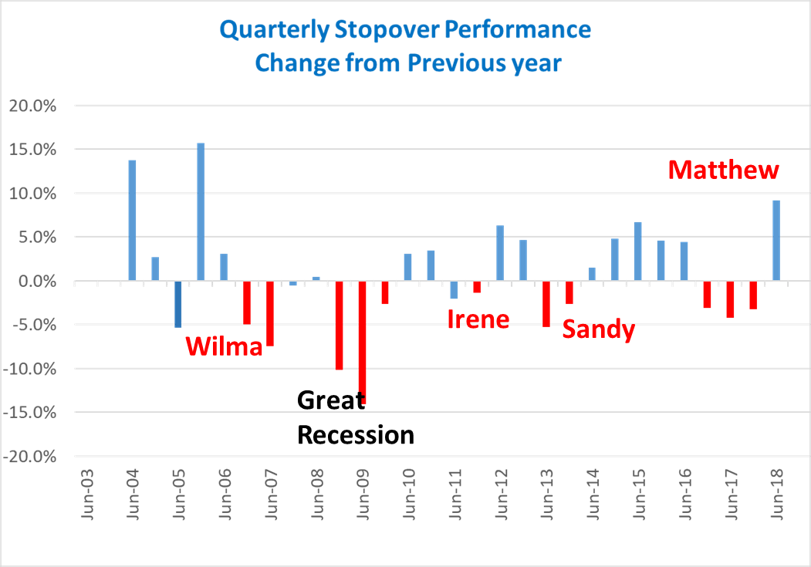
Source: Bahamas Ministry of Tourism Data

Figure 2: Recent Fiscal Balances Trends vs Hurricane Occurrences
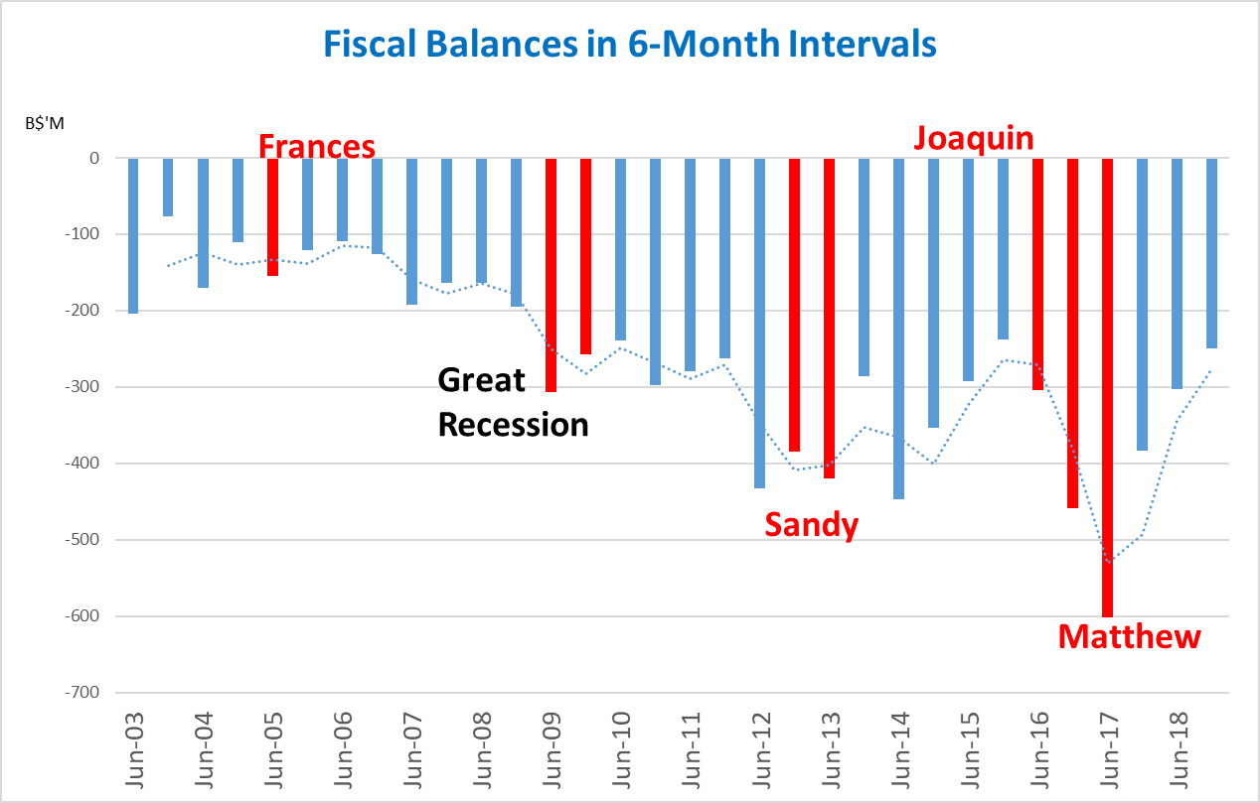
Source: Central Bank of The Bahamas

Figure 3: Hurricane Induced Re-insurance Inflows
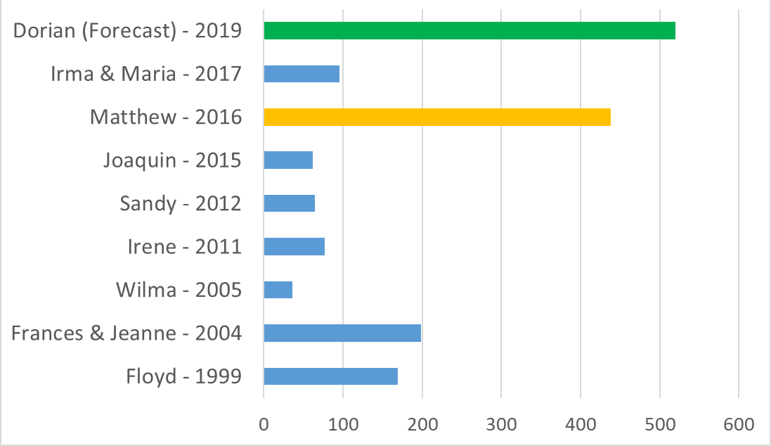
Source: Central Bank of the Bahamas and preliminary feedback from insurance industry.

Figure 4: Commercial Banks — Selected Credit Exposure Indicators (2019)

4A:Credit Shares by Island  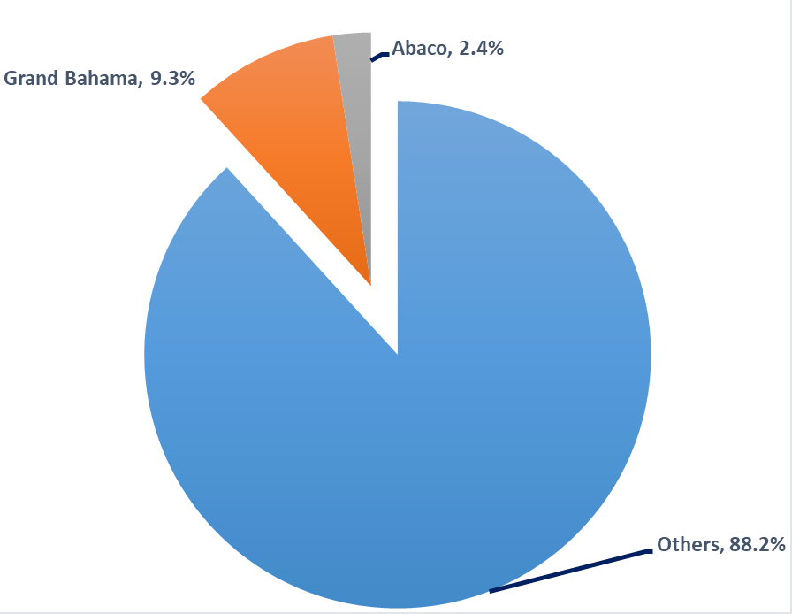 | 4B: Non-Performing Loans (NPL) Rate  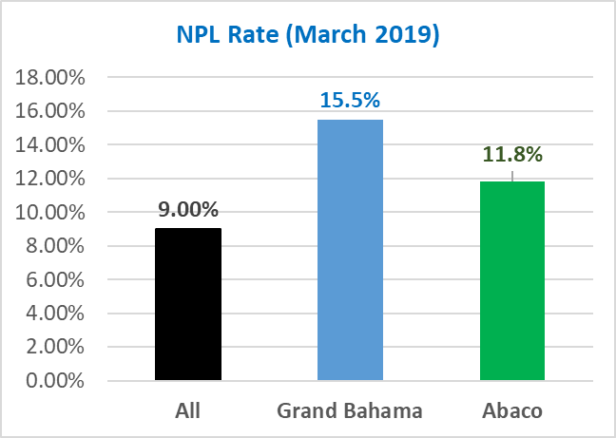

Source: Central Bank of The Bahamas survey.

Disaster response for the Government normally included major expenditures on infrastructure rebuilding, social and humanitarian assistance, subsidies to un-insured and underinsured households and tax concessions on private sector recovery expenditures. At the same time, base of remaining taxable commercial activities decreases.
It should be emphasized, however, that MTBs were made aware of the continued expectation to exercise due care and attention to prevent the occurrence of fraudulent activities in order to safeguard the integrity of the financial sector.
These simulations were refined in close collaboration with the IMF, during the recent Financial Sector Assessment Program (FSAP) mission.
Credit exposures to Grand Bahama and Abaco totalled $658.8 million and $170.8 million, respectively. Moreover, residential mortgages represented 54.8% of the aggregate portfolio ($343.9 million in Grand Bahama and $111.0 million in Abaco).
This is a debt management strategy collectively agreed between the Central Bank and the Ministry of Finance, in order to offset any balance of payment strain from import financing around rebuilding activities.
Physical resilience encompasses structural measures aimed at mitigating the impacts of natural disasters. It includes investment in infrastructure including new structures, upgrades to existing ones; and developing and fine tuning policies related to zoning, building codes, land use, early warning systems and “risk maps”. The social resilience element comes into play post-disaster. It involves the response of the government, wider community and relevant organizations to the various humanitarian needs that exist following the occurrence of a natural disaster. The relevant authorities must be able to ensure minimal interruption in national security, emergency medical care services and essential utilities. Additionally, the established frameworks must ensure that aid to the adversely affected population is efficiently distributed without undue delays and abuses.
In April 2019, the Government secured access to a contingent loan from the IADB for natural disasters in the amount of $100 million. Access following the passage of Hurricane Dorian will finance disaster recovery expenses, including on infrastructure repair and social and humanitarian assistance.
The Bahamas will also be able to continue to leverage support from the international community, of which it is a part and to which the country also contributes when others face tragedies. It includes invaluable access to technical assistance, specialized skills that permit accelerated the rebuilding, and generous financial donations.
After the Hurricane, technical assistance materialized from within the regional multiple disaster response agencies within CARICOM, the various United Nations bodies, the IMF, IDB and the World Bank. Technical assistance weighted heavily in all responses.

